**CHAPTER SEVEN;** **CONCLUSIONS, FINDINGS AND RECOMMENDATION**

**7.1 Introduction**

This section elaborates on the concluding comments and recommendations of the developed wedding management system. These comprise; findings and challenges faced during the analysis, design, and implementation. Additionally, it elaborates conclusions, recommendations, and suggestions for future work related to the wedding management system.

**7.2 Challenges encountered**

• **Customization and Personalization**: Every wedding is unique, and clients often want highly customized solutions. Managing and integrating various preferences, themes, and requirements can be challenging.

• **Vendor Coordination**: Coordinating with multiple vendors (caterers, florists, photographers, etc.) and ensuring their availability and reliability can be difficult. A system must effectively manage these relationships and keep track of bookings and contracts.

• **Budget Management**: Keeping track of expenses and staying within budget is crucial. The system must handle various costs, from deposits to final payments, and provide real-time budget tracking and adjustments.

• **Guest Management**: Managing guest lists, RSVPs, seating arrangements, and special requests requires careful attention. Systems need to efficiently handle these details and provide easy access to updated information.

• **Scheduling and Timeline Management**: Coordinating the wedding schedule, including rehearsals, ceremony, and reception, can be complex. The system needs to provide a clear timeline and allow for adjustments as needed.

• **Data Security and Privacy**: Handling sensitive personal information such as guest details and financial transactions requires robust security measures to protect against data breaches and unauthorized access.

**7.3 Future Recommendation**

• **Advanced Budget Tracking and Financial Management**: Implement more sophisticated financial tools, including real-time expense tracking, budget forecasting, and financial reporting. This could include automated alerts for budget overruns or upcoming payments.

• **Real-Time Collaboration and Communication Tools**: Develop in-system communication features such as chat, video calls, and document sharing to facilitate real-time collaboration between couples, planners, and vendors.

• **Mobile Optimization and Apps**: Ensure that the system is fully optimized for mobile devices and consider developing dedicated mobile apps for both clients and vendors to manage tasks on the go.

• **Interactive Guest Management**: Introduce interactive features for guest management, such as online RSVPs with meal choices, accommodation booking links, and real-time updates on event details.

**7.4 Conclusion**

Wedding management system plays a crucial role in streamlining the complex and multifaceted process of organizing weddings. By integrating various functionalities such as vendor coordination, budget tracking, guest management, and timeline organization, these systems facilitate a more organized and efficient planning experience

**References / Bibliography**

Bansal, S.K. (2012).Information System Management. New Dehli: APH Publishing Corporation.

Baron R. A &Byrne D. (1987). Social psychology: Understanding human inter-action. Boston: Allyn & Bacon.

Cramer, K, & Lafreniere, K. (2003). Wedding preparation stress: Results of a pilot study. Guidance & Counseling, 19(1), 18-27. Retrieved from <http://www.utpguidancecentre.com/>

Davis, N. (2000). Bridal style. Southport, CT: Hugh Lauter Levin Associates.

Dosh, C. (2008, May).Counting change. Successful Meetings, 57(6), 40-45.

Grossman, C. (2012, August 10).

**7.5 Appendix**

**7.5.1 Sample interviews**

This interview is strictly for academic research and no other purpose all data provided in this document is confidential and participation is voluntary

• **What project management methodologies have you used in previous roles, and which would you apply to managing a wedding management system project?**

• **How would you handle scope changes or new feature requests during the development of a wedding management system?**

• **Can you provide an example of how you managed stakeholder expectations and ensured clear communication throughout a project?**

• **Describe your approach to managing a cross-functional team that includes developers, designers, and vendors.**

• **How do you prioritize tasks and manage deadlines when working on a complex project like a wedding management system?**

• **What risk management strategies do you employ to address potential challenges in project delivery. 7.5.2 Sample Questionnaires**

• **User Requirements:**

* What are the most critical user requirements for a wedding management system?
* How do you plan to incorporate user feedback into the system design?

• **Technical Specifications:**

* What technologies and frameworks will you use for developing the system?
* How will you ensure the system is scalable and secure?

• **User Experience:**

* How will you design the user interface to be intuitive and easy to use for all types of users?
* What methods will you use to test and validate the system’s usability?

• **Integration and Features:**

* What third-party services or integrations are essential for the system?
* How will you address the customization needs of different users?

• **Maintenance and Support:**

* How will you handle system updates, bug fixes, and ongoing maintenance?
* What support resources will you provide to users?

**7.5.3 BUDGET SCHEDULE.**

|  |  |  |
| --- | --- | --- |
| **PARTICULARS** | **Item** | **COST IN KES** |
| Laptop -Os (at least windows 7) platform, ram is 750gb, | 1 | 35000 |
| Flash disk 16GB --For storing copies usually when taking them to be printed and also highly can be used as a backup tool. | 1 | 2500 |
| External hard disk drive --Backup tool. | 1 | 8000 |
| Printing expenses – copies to be submitted to my supervisors. | 1 | 3000 |
| Transport and Research costs |  | 2000 |
| Miscellaneous |  | 3000 |
|  | **Total** | 53500 |

**7.5.4 TIME SCHEDULE.**

|  |  |  |  |  |  |  |  |  |
| --- | --- | --- | --- | --- | --- | --- | --- | --- |
| **Activity/Month** | **October** | **November** | **December** | **January** | **February** | **March** | **April** | **May** |
| **Project proposal** |  |  |  |  |  |  |  |  |
| **Field Study** |  |  |  |  |  |  |  |  |
| **Analysis** |  |  |  |  |  |  |  |  |
| **Design** |  |  |  |  |  |  |  |  |
| **Coding** |  |  |  |  |  |  |  |  |
| **System testing** |  |  |  |  |  |  |  |  |
| **Project Release** |  |  |  |  |  |  |  |  |
| **Project documentation** |  |  |  |  |  |  |  |  |

**7.5.5 SAMPLE CODE.**

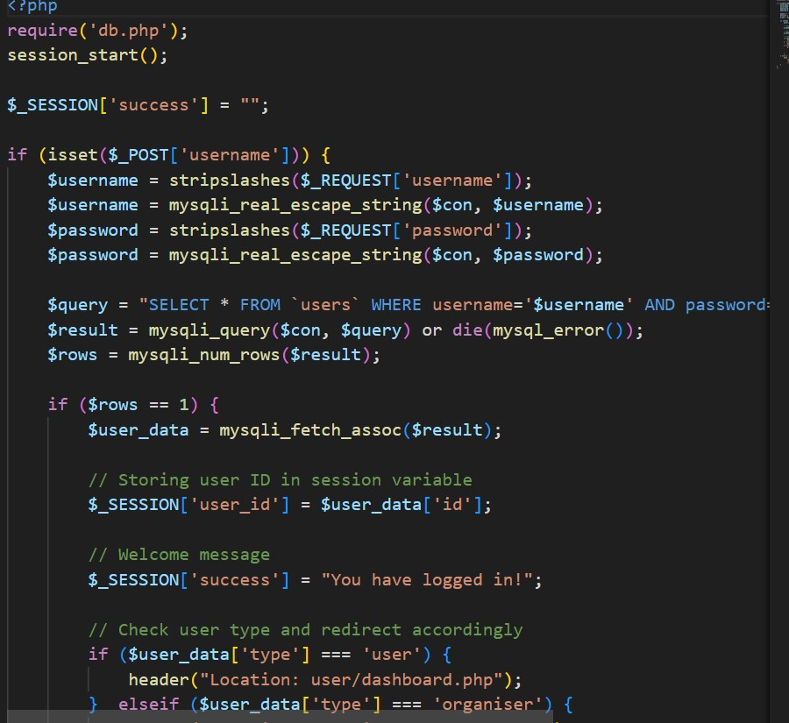

**7.5.6 SAMPLE CODE TWO.**

